Tennis Elbow
Tennis elbow (lateral epicondylitis) is a painful and very common elbow problem. Tennis elbow is caused by wear and tear degeneration within the extensor carpi radialis brevis (ECRB) tendon on the outside of the elbow. Despite the name, tennis elbow is not just limited to tennis players. Tennis elbow is often diagnosed in patients between the ages of 30 and 50, many of whom have never played tennis.
Patients experience pain on the outside of the elbow and often point to a very tender spot near the lateral epicondyle bony prominence. Symptoms can be aggravated by a forceful, repetitive activity with the hand and wrist, such as the tennis backhand swing or heavy gripping. Lifting light objects with the palm down, gripping the steering wheel, and even simple household activities can be painful. The majority of patients with tennis elbow improve with non-operative treatment, although symptoms may take several weeks or months to go away. Once tennis elbow goes away it is unlikely to return.

Non-operative Treatment Options:

Braces: Wearing a forearm strap or wrist splint

Activity modification: Resting, avoiding repetitive, heavy lifting or forceful gripping

Medications: Taking anti-inflammatory medications such as Motrin, Naproxen, or Tylenol

Stretches: Stretching the muscles of the hand, wrist, and elbow with exercises

Hand Therapy: A therapist can guide tennis elbow exercises and perform pain-relieving treatment

Corticosteroid injection: Anti-inflammatory injection targeting the degenerative ECRB tissue can be used to reduce pain
Tennis Elbow Rehab Exercises
These exercises are intended to increase flexibility and decrease pain from tennis elbow over 4-6 weeks. Each session is performed 2-3 times per day. If you are experiencing more pain or aggravated symptoms, discontinue the program and contact your physician.
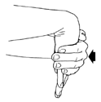
Exercise 1. Stretching the muscles that extend the wrist: straighten the elbow and arm out fully with the palm down and push the wrist downward so you feel a stretch across the top of the forearm. Hold the stretch for about 10 seconds. Repeat 2-3 times.

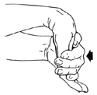
Exercise 2. Stretching the muscles that flex the wrist: straighten the elbow and arm out fully with the palm up, and pull the wrist backwards to stretch. Hold the stretch for about 10 seconds. Repeat 2-3 times.

Light strengthening exercises are performed after stretching. You should sit on a chair with the elbow and forearm supported on a table or the arm of a chair with the hand and wrist hanging over the edge. Use a light weight such as a soup can or hammer when performing these exercises. Repeat the strengthening exercises 10 times but do push beyond the point of pain.
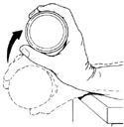
Exercise 3. Strengthening wrist extensor muscles: hold the weight in the hand with the palm facing down. Extend the wrist upward so that it is pulled back. Hold this position for 2 seconds then lower slowly.

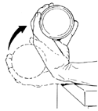
Exercise 4. Strengthening wrist flexor muscles: Hold the weight in the hand with the palm up. Pull with wrist up, hold this position for 2 seconds then lower slowly.

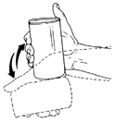
Exercise 5. Strengthening the muscles which move the wrist from side to side: Hold the weight in the hand with the thumb pointing up. Move the wrist up and down, much like hammering a nail. All motion should occur at the wrist, not the elbow.

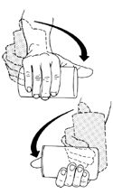
Exercise 6. Strengthening the muscles which twist the wrist and forearm (pronation and supination): Hold the weight in the hand with the thumb pointing up. Rotate the wrist inward as far as comfortable and then rotate outward as far as comfortable. Hold for 2 seconds in each direction and repeat up to 10 times.

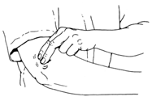
Exercise 7: Massage is performed over the area of soreness. Apply firm pressure using 2 fingers on the area of pain and rub for 5 minutes.

